Ideation Phase
Empathize & Discover

Date | 02 November 2025
Team ID | NM2025TMID07661
Project Name | Streamlining Ticket Assignment for Efficient Support Operations
Maximum Marks | 2 Marks

Empathize & Discover:
Goal: Understand the needs, challenges, and experiences of users (Support Agents, Team Leads, Customers).

Activities:
- User interviews and observation of ticket workflow
- Creation of empathy map for agents, leads, and customers
- Identification of pain points like manual assignment, workload imbalance, and delayed responses

Insights:
- Agents need automated prioritization and fair workload
- Leads need real-time monitoring dashboards
- Customers want fast resolution and transparency

Problem Statement:
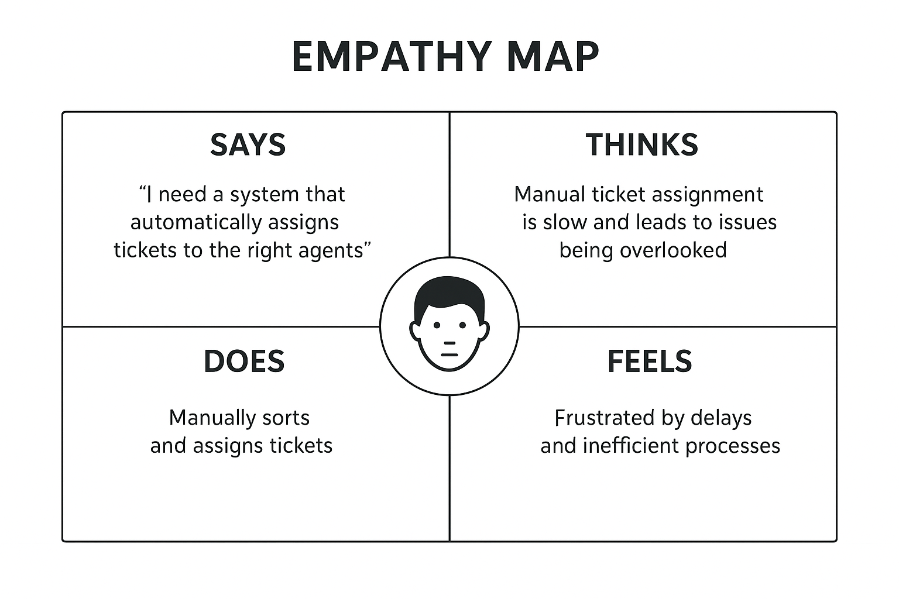
Example:
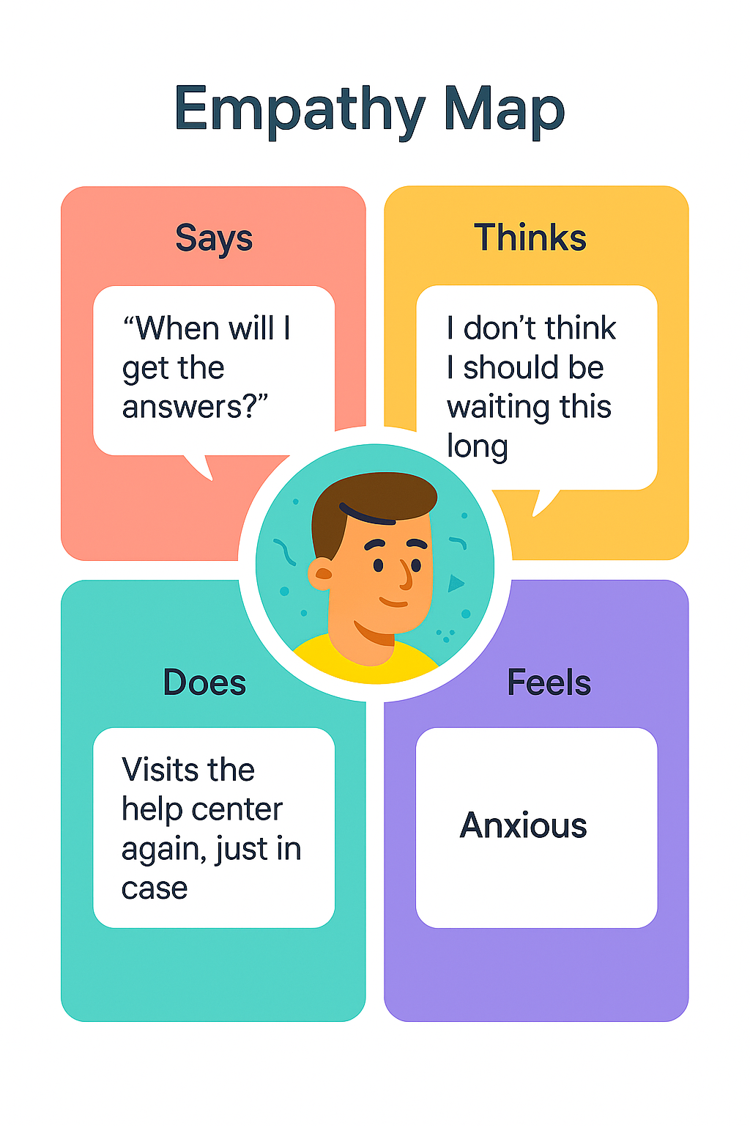

Reference:
https://www.cuppa.so/post/how-to-streamline-your-ticketing-process

